$Interval estimate=point Estimate±K*Standard error$

$IE=PE±z^{*}SE$

$90\%CI=P E±1.645*SE$

$95\%CI=P E±1.96*SE$

$99\%CI=P E±2.58*SE$

$90\%==== >100-90=10\%=\frac{10}{100}=0.1$

1.6+0.045=1.645

0.04 -0.05: 0.045

$95\%==== >100-95=5\%=\frac{5}{100}=0.05$

$99\%==== >100-99=1\%=\frac{1}{100}=0.01$

Construct 80% Interval estimate?

$Step-1:80\%====>100-80=20$

$Step-2:\frac{20}{100}=0.2$

$Step-3:Go to Z-table find where 0.2 is avialble$

$Step-4:1.2+0.08=1.28$

$Step-5=[PE-1.28*SE to PE+1.28*SE]$

What is Exactly 95% Confidence means?

Step-1: we have a raw data

Step-2: Divide raw data into 100 parts

Step-3: Calculate mean of those 100 parts

100 means will get ========= > 100 Point estimates

Step-4: Now calculate Interval estimates

Pe – z* SE to Pe+Z* SE

Step-5 : construct 95% CI z= 1.96

100 Interval estimates

PE – 1.96*SE to PE+1.96*SE

Out of these 100 interval estimates I’m confident at least 95 interval capture population mean

I divided in 20 parts , I do same steps

Im 95% Confident out of 20parts 19 parts

Hypothesis testing:

Example:

Sourav says that sir The average salary of NareshIT in DS is 8LPA

Zubair/Mobin/Srikanth ========== test this True or not

Step-1: You go to Naresh IT management

Step-2: 2023 all DS batch people (1000)

Step-3: Who already got the job (100)

Step-4: call to each person ask the details

Step-5: calculate the average salary ============ 8LPA

We have two cases

1. Null Hypothesis
2. Alternative hypothesis

${Null Hypothesis: H}_{o}$

${Alternative Hypothesis: H}_{a} or H_{1}$

1)Sourav says that sir The average salary of NareshIT in DS is 8LPA

${Null Hypothesis: The average salary is 8lpa }_{}$

$Alternative Hypothesis: The average salary not equal to 8LPA$

$H_{o}:U=8$

$H_{A}:U≠8$

2)The average sleep time of Naresh IT students

${Null Hypothesis: The average sleep time is 10hours }_{}$

$Alternative Hypothesis: The average sleep time is not equal to 10hours$

$H_{o}:U=10$

$H_{A}:U≠10$

3)The average of VK in ODI is 60

Step-1:

${Null Hypothesis: VK batting average in ODI is 60 }_{}$

$Alternative Hypothesis: VK average batting average is not equal to 60$

$H_{o}:U=60$

$H_{A}:U≠60$

Step-2:

Significance level

When you do any statistical test , you never come with 100% proof

$Significance level=α$

$α=5\%=0.05== >It is okay we can gather 95\% proof$

$α=1\%=0.01== >It is okay we can gather 99\% proof$

Step-3:

$Critical values:$

$Significance level=α=5\%=95\%$

$what are the z-values for 95\%=1.96$

$Critical values= -1.96 and 1.96$

Step-4: Rejection and Non rejection area

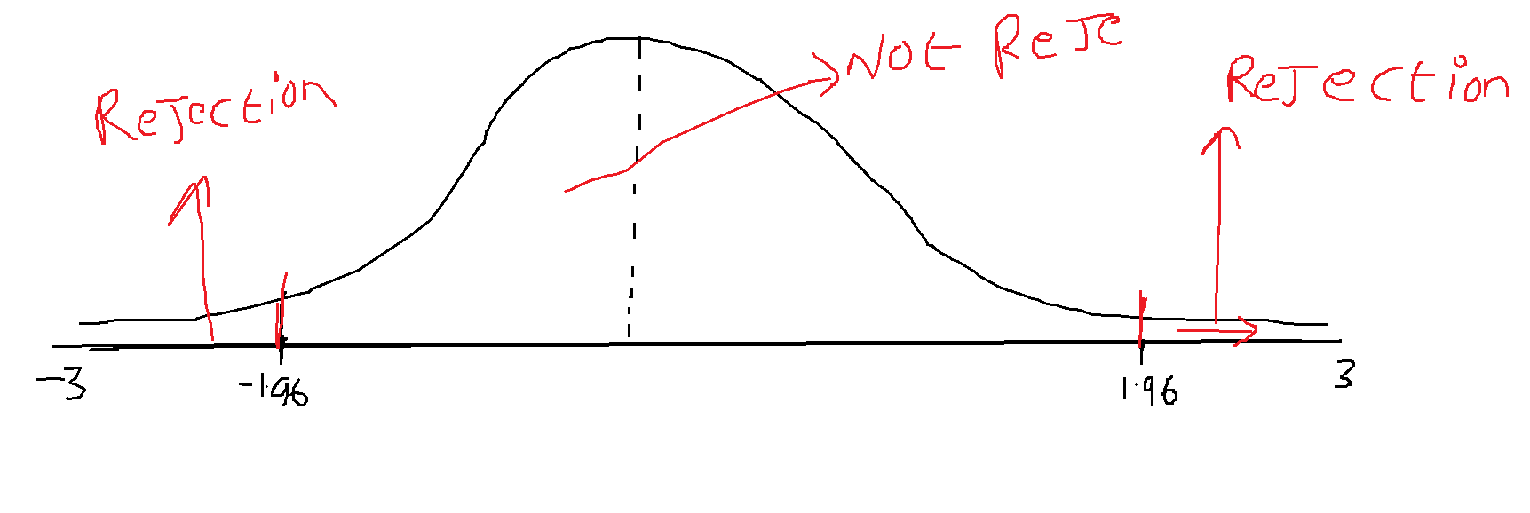

Step-5: Z-test

If you conduct a test on mean , we need follow two tests

1. Z
2. T

If you conducting test on variance , will do f-test

If you conductin test on cate variables : chi-square = x

$z-test=\frac{\underline{s}-\underline{u}}{\frac{σ}{\sqrt{n}}}$

In the testing process will gather some samples ========= > $\underline{s}$

$z-test=\frac{\underline{s}-60}{SE}$

Case-1: $\underline{s}=40$

$z-test=\frac{40-60}{SE}$

Case-2: $\underline{s}=60$

$z-test=\frac{60-60}{SE}$

Case-3: $\underline{s}=55$

$z-test=\frac{55-60}{SE}=1.2$

$observed values=1.2$

Step-6:

Conclusion:

$Cv=1.96$

$ov=1.2======= >falls in Not rejected area$

$we not able to reject the Null hypothesis i.e yes VK avg is 60$

**Question-1:**

In an attempt to determine why customer service is important to managers in the United Kingdom, researchers surveyed managing directors of manufacturing plants in Scotland.* One of the reasons proposed was that customer service is a means of retaining customers. On a scale from 1 to 5, with 1 being low and 5 being high,

The survey respondents rated this reason more highly than any of the others, with a mean response of 4.30. Suppose U.S. researchers believe American manufacturing managers would not rate this reason as highly and conduct a hypothesis test to prove their theory. Alpha is set at .05. Data are gathered and the following results are obtained. Use these data and the eight steps of hypothesis testing to determine whether U.S. managers rate this reason significantly lower than the 4.30 mean ascertained in the United Kingdom. Assume from previous studies that the population standard deviation is 0.574.

3 4 5 5 4 5 ==== 26

5 4 4 4 4 4 ===== 25

4 4 4 5 4 4 ===== 25

4 3 4 4 4 3 ====== 22

5 4 4 5 4 4 ===== 26

4 5 ====9

Step-1:

Make the hypothesis

$H_{0}:Mean response is 4.30$

$H_{a}:Mean response is not equal to 4.30$

**Step-2:**

$H_{0}: u=4.30$

$H_{a}: u≠4.30$

**Step-3:**

**Significance value :**

$α=0.05$

***Step-4:***

***Make critical values***

***1.645 ============ 90%***

***1.96 ============== 95%***

***2.58 ============== 99%***

***Critical values are -1.96 to 1.96***

***Step-5:***

***Make a rejection area and non rejection area***

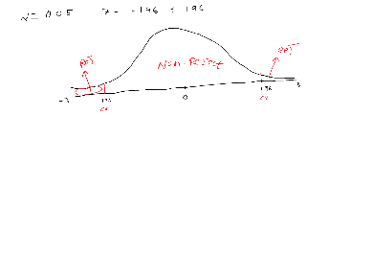

**Step-6:**

**Conduct the test**

3 4 5 5 4 5

5 4 4 4 4 4

4 4 4 5 4 4

4 3 4 4 4 3

5 4 4 5 4 4

4 5

Sample mean = 4.15

$z=\frac{4.15-4.30}{0.574∕\sqrt{32}}= -1.48$

$obsrved value= -1.48$